MONGODB (Assignment-3)
Collection name :- students
db.students.insertMany([{student_id:1,name:"Amit",age:20,marks:85,department:"CSE",subjects:["DBMS","OS","CN"],email:"amit@gmail.com"},
{student_id:2,name:"Neha",age:22,marks:72,department:"ECE",subjects:["Signals","VLSI"],email:null},
{student_id:3,name:"Rahul",age:19,marks:90,department:"CSE",subjects:["DBMS","AI","ML"]},
{students_id:4,name:"Sneha",age:21,marks:65,department:"IT",subjects:["Web","DBMS"],email:"sneha@gmail.com"},
{student_id:5,name:"Karan",age:23,marks:78,department:"CSE",subjects:["CN","OS"],email:"karan@gmail.com"}])

Que-1 :- Find students with marks greater than 80.
Answer:- code= db.students.find({marks:{$gt:80}})
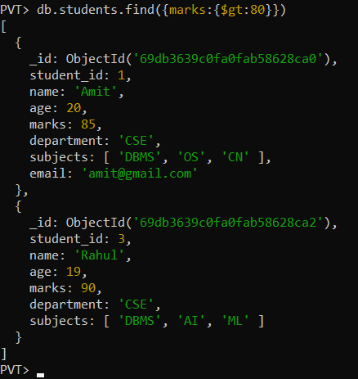

Que_2:- Find students aged less than or equal to 20
Answer:- code = db.students.find({age:{$lte:20}})
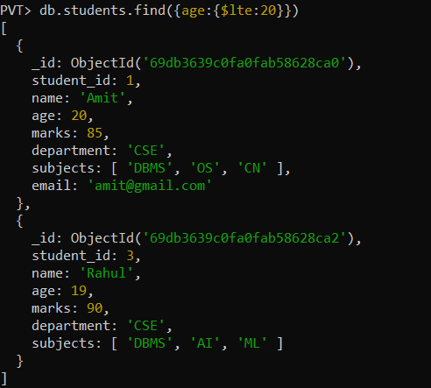
Que_3 :- Find students with marks between 70 and 85.
Answer:- code= db.students.find({marks:{$gte:70,$lte:85}})
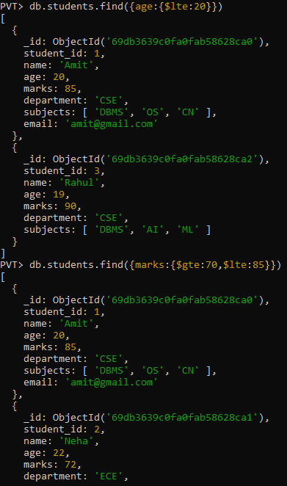
Que_4= Find students not belonging to CSE department.
Answer :- code=db.students.find({department:{$ne:"CSE"}})
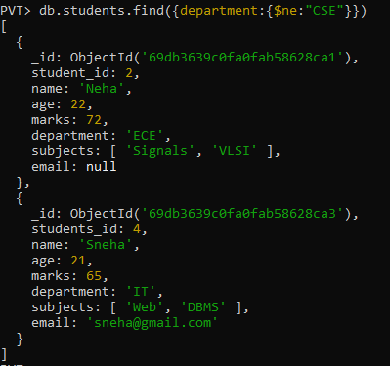
Que_5:- Find students whose age is exactly 21.
Answer:- code=db.students.find({age:21})
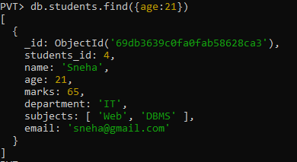
Que_6:- Find students with marks less than 75
Answer:- code= db.students.find({marks:{$lt:75}})
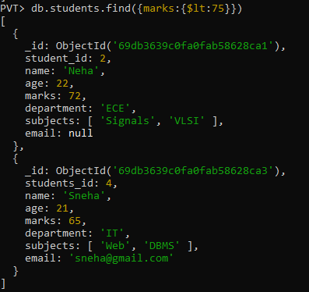
Que:7= Find students whose department is either CSE or IT
Answer:- code= db.students.find({department:{$in:["CSE","IT"]}})
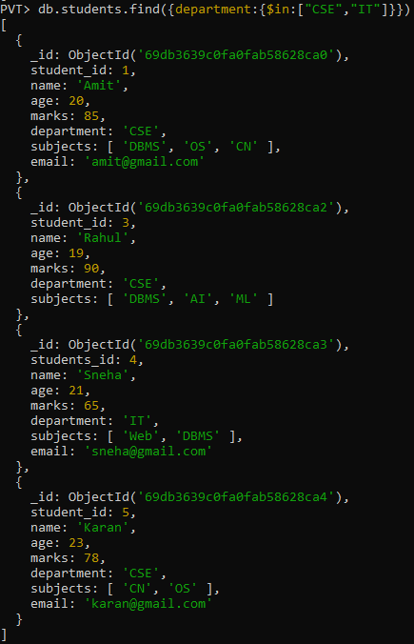
Que_8=Find CSE students with marks above 80.
Answer:- code= db.students.find({department:"CSE",marks:{$gt:80}})
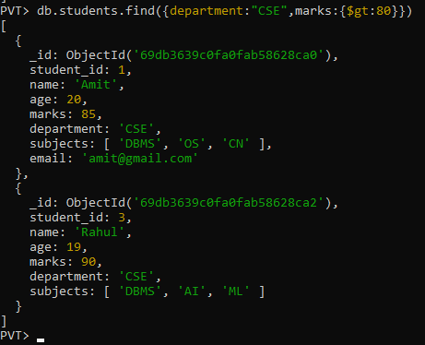
Que_9 :- Find students who are in CSE or have marks above 85
Answer:- code= db.students.find({$or:[{department:"CSE"},{marks:{$gt:85}}]})
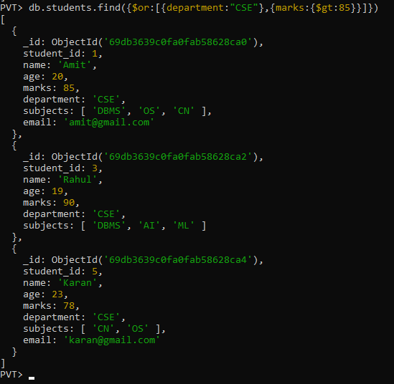
Que_10:- Find students who are NOT in IT department
Answer :- code= db.students.find({department:{$ne:"IT"}})
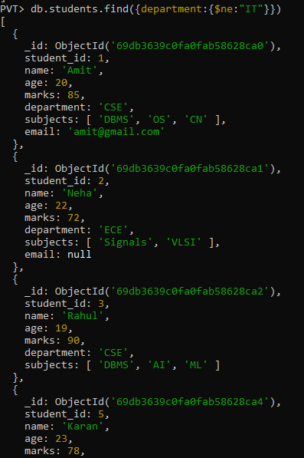
Que_11= Find students with marks not between 70 and 85
Answer :- code= db.students.find({marks:{$not:{$gte:70,$lte:85}}})
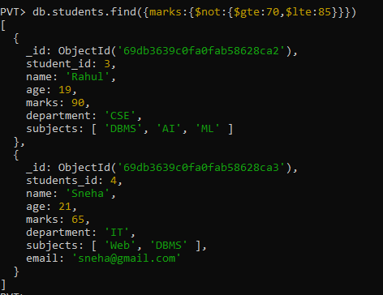
Que_12:- Find students aged above 20 and not in ECE.
Answer:- code= db.students.find({age:{$gt:20},department:{$ne:"ECE"}})
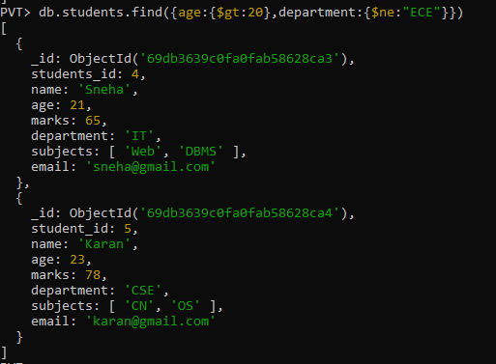
Que_13:- Find students who are either IT students or have marks less than 70.
Answer:- code= db.students.find({$or:[{department:"IT"},{marks:{$lt:70}}]})
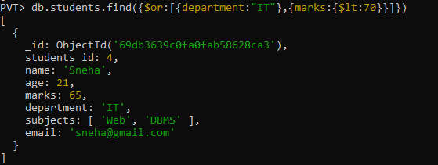
Que_14 :- Find students who are not CSE and not IT.
Answer:- code= db.students.find({department:{$nin:["IT","CSE"]}})
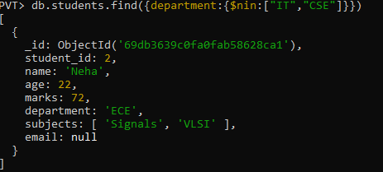
Que_15 :- Find students who have an email field.
Answer :- code=db.students.find({email:{$exists:true}})
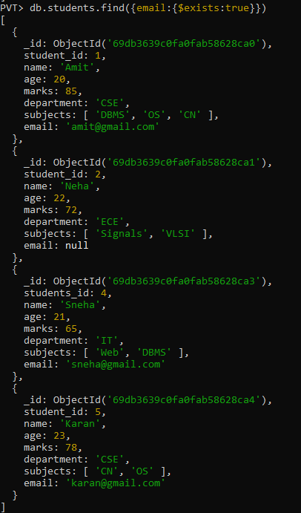
Que_16 :- Find students who do not have an email field.
Answer :- code= db.students.find({email:{$exists:false}})
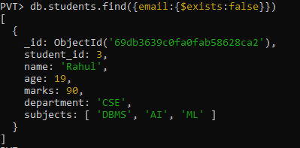
Que_17 :- Find students whose email value is null.
Answer :- code= db.students.find({email:{$type:"null"}})
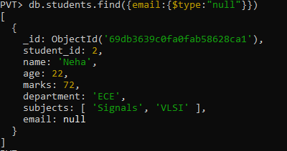
Que_18:- Find students whose marks field is of type integer.
Answer :- code= db.students.find({marks:{$type:"int"}})
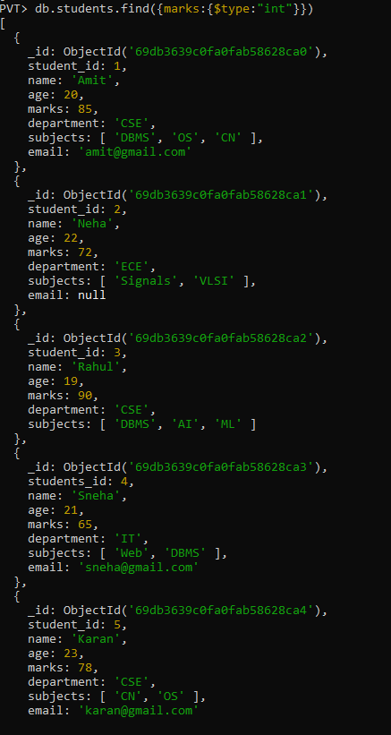
Que_19 :- Find students who have subjects’ field.
Answer:- code= db.students.find({subjects:{$exists:true}})
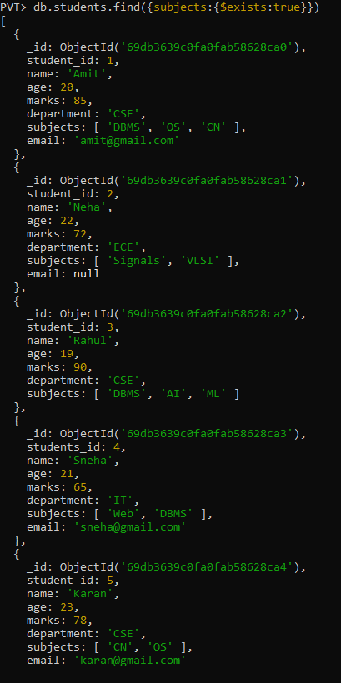
Que 20 :- Find students whose age field is missing.
Answer:- code= db.students.find({age:{$exists:false}})
Explanation :- There is no students whose age field is missing.
Que_21:- Find students where marks modulo 5 equals 0.
Answer :- code= db.students.find({marks:{$mod:[5,0]}})
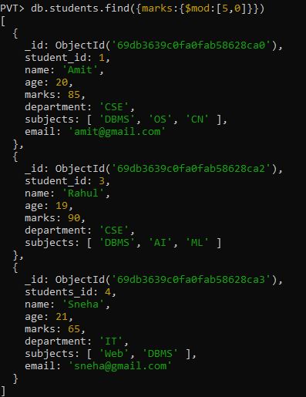
Que_22:- Find students whose name starts with letter “A”.
Answer :- db.students.find({name:{$regex:"^A"}})
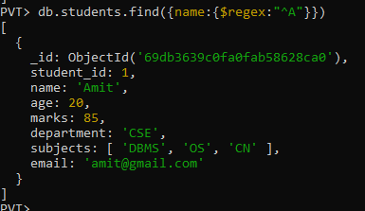
Que_23 :- Find students whose email ends with gmail.com.
Answer : code= db.students.find({email:{$regex:"gmail.com$"}})
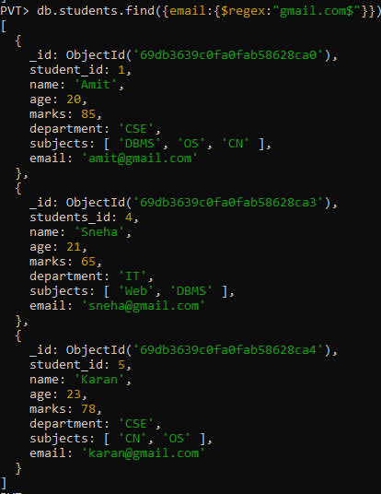
Que _24 :- Find students who have more than 2 subjects.
Answer :- code= db.students.find({"subjects.2":{$exists:true}})
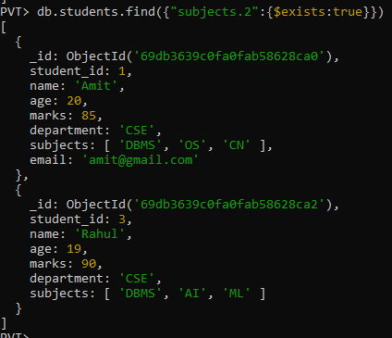
Que _25 :- Find students whose marks are greater than their age × 3.
Answer :- db.students.find({$expr:{$gt:["$marks",{$multiply:["$age",3]}]}})
